ENR 112: LINEAR ALGEBRA LABORATORY

PROJECT REPORT

Name | Prina Patel
Enrolment No. | AU2340040

PROJECT TITLE: Finding Rate Of Chemical Reaction Using Matrix Algebra

Introduction-
In this project, we focus on modelling and simulating the concentrations of reactants and products that are involved in a coupled chemical reaction. The reaction will be as follows-
𝐴 → 𝐵 → 𝐶

A –-k1- –> B– -k2- –> C

Here, A is the reactant, B is the intermediate, and C is the product. k1 and k2 are the rate constants that determine the rate at which each substance is consumed or formed.
We will use matrix algebra (matrix exponentiation) to solve the system of ordinary differential equations (ODEs) that controls the concentrations of the substances that are involved in
coupled chemical reactions.

Objective-
The main objective of this project is to
  - Simulate the concentrations of the chemical substances A, B, and C over time.
  - Using matrix algebra to solve the system of differential equations.
  - Visualizing the concentrations of the substances over time through plots.

Modelling the system (Equations)-
Substance A is converted to B, so the concentration of A will decrease Therefore, the equation for the substance A will be:

𝑑[𝐴]

𝑑𝑡

= −𝑘1[𝐴]

Substance B is intermediate. B first increases when A is converted to B, then decreases when B is further converted to C.
Therefore, the equation for substance B will be:

𝑑[𝐵]

𝑑𝑡

= 𝑘1[𝐴] − 𝑘2[𝐵]

Substance C is the product. C initially starts at 0 and increases when B is converted into C. It continues to rise as the time passes.
Therefore, the equation for substance C will be:
𝑑[𝐶]

𝑑𝑡
= 𝑘2[𝐵]

- [A], [B], and [C] are the concentrations of substances A, B, and C, respectively.

- k1 and k2 are rate constants governing the speed of the conversion of A to B and B to C, respectively.

Now, the system of equations can be written in the matrix form as follows: d ( [A][B][C] ) / dt =[−k1, 0 , 0 ; k1, −k2, 0 ; 0, k2, 0] * ( [A][B][C] )

[𝐴]

−𝑘1 0 0
[𝐴]

^{𝑑} [𝐵] = |
𝑑𝑡
𝑘1 −𝑘2 0 | * [𝐵]

[𝐶]
0 𝑘2 0 [𝐶]

Let K = rate constant matrix
−𝑘1 0 0

K= |
𝑘1 −𝑘2 0 |
0 𝑘2 0

Let C = concentration vector
[𝐴]
C = [𝐵]
[𝐶]

The solution to this system can be represented as:
𝐶(𝑡) = exp(𝐾𝑡) ∗ 𝐶0

Where C0 is the initial concentration vector, and exp (Kt) is the matrix exponential of the rate constant matrix multiplied by time.

Procedure – For MATLAB

4.1- Define Rate Constant Matrix
The matrix K can be defined as follows:

K= |
−𝑘1 0 0
𝑘1 −𝑘2 0 |
0 𝑘2 0

Let k1=0.5 and k2=0.3 be the rate constants for the reaction.

4.2- Define Initial Concentrations
Let the initial concentrations of the substances be:
[1]
C0= [0]
[0]
So, initially, only substance A will be present at concentration 1, while B and C will have concentrations of 0.

4.3- Time Range
Here, let the time range be from 0 to 20 with 100-time steps.

4.4- Using Matrix Algebra to Solve ODEs
Matrix algebra can be used to calculate the concentration of A, B, and C.
𝐶(𝑡) = exp(𝐾𝑡) ∗ 𝐶0
To compute the matrix exponential of Kt, the expm function of MATLAB is used. Multiplying it by the initial concentration vector gives the concentrations at that time point.

4.5- Plotting Results
The concentrations of A, B, and C are plotted against time using MATLAB’s plot function.

MATLAB CODE-
% PROJECT- Calculating Rate Of Chemical Reaction Using Matrix Algebra
% Step 1: Defining the rate constant matrix
%let rate constant for A to B = k1 k1 = 0.5
%let rate constant for B to C = k2 k2 = 0.3

K = [
-k1, 0, 0;
k1, -k2, 0;
0, k2, 0
]

% Step 2: Defining the initial concentrations
% for substance A, B, C respectively C0 = [1; 0; 0]

% Step 3: Defining the time range (0 to 20) with 100 steps
t = linspace(0, 20, 100);

% Step 4: Solving for concentrations using matrix algebra C = zeros(3, length(t));

%C stores concentrations of ([A], [B], [C])

%number of rows are 3. It corresponds to the three
% substances ([A], [B], and [C])

%the number of columns are (length(t))
%It corresponds to number of time points.

for i = 1:length(t)
C(:, i) = expm(K * t(i)) * C0; % Matrix exponential solution end

% Step 5: Plotting the concentrations over time figure;
plot(t, C(1, :), 'r-', 'LineWidth', 1.5, 'DisplayName', '[A] (Reactant)'); hold on;
plot(t, C(2, :), 'b-', 'LineWidth', 1.5, 'DisplayName', '[B] (Intermediate)');
plot(t, C(3, :), 'g-', 'LineWidth', 1.5, 'DisplayName', '[C] (Product)'); hold off;

% Step 6: Adding labels and legend xlabel('Time');
ylabel('Concentration');
title('Concentration vs. Time for Coupled Reactions');
legend('show', 'Location', 'northeast'); %show legend with labels from 'DisplayName' grid on;

Result-

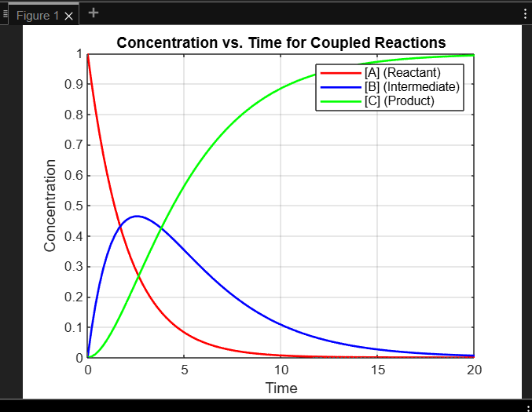

Graph from MATLAB
(Representation of the changes in concentrations of reactants and products according to the rate constants)

The concentrations of A, B, and C are plotted with respect to time
- From the graph, we can see that A gradually decreases from 1 to 0. A is converted to B, so its concentration decreases.
- In the graph, B first increases (as A is converted to B), then it decreases (as B is further converted to C).
- C initially starts at 0 and then increases when B is converted into C. It continues to rise as time passes.

6. Applications:
  - Chemical Engineering
  - Medicine and Biochemistry
  - Nuclear Chemistry
  - Energy Production
  - Food Industry

